Website proposal
  - Helping companies build international growth that lasts.
For internal Use • Prepared by Carin • August 2026

VeliD Advisory → the brand
Growth that lasts. → the brand idea / tagline Helping companies build international growth that lasts.
Website must-have: Copyright disclaimer, cookie OK for Europe, perhaps data protection claimer for contact form.

Purpose:
The purpose of this website is to persuade potential customers to book a videocall to start a sales conversation (a.k.a. Strategic First Conversation)

Objectives:
Primary objective: Generate qualified 30-minute discovery/strategy calls with SME decision-makers who have a cross-border growth, market-entry, repositioning or sustainability challenge.
Secondary objective: Establish Carin/VeliD Advisory as a credible strategic advisor before the first conversation.

What I offer:
Strategic support for “SMEs” entering new markets, repositioning their offer, and building sustainability into their growth strategy.
I help internationally ambitious companies enter new markets, rethink their strategy, and build sustainability into how they grow. Based on hands-on experience in Mexico, not AI or borrowed opinions. I believe in collaboration and creating shared value that benefits everyone.
- The entire site should answer this question for the visitor: “Does Carin understand my problem, and is it worth spending 30 minutes talking to her?”
If the answer becomes yes → Book a free consultation.
Which leads to the following funnel: Recognize the problem → Trust Carin → Understand how she works → See relevance/proof → Book the call
It is important to clarify the value of the meeting: 30 minutes. One strategic conversation. No obligation. We'll look at where you are, what's getting in the way, and whether there is a meaningful role for VeliD.
It should feel like: You have a difficult international growth question. I understand these problems. I've been in the market. Here's how I think about them. Let's spend 30 minutes figuring out whether I can help.

Positioning:
I spent 19 years living in Mexico of which 7,5 leading the Dutch Chamber of Commerce, where I accompanied Dutch and Mexican businesses seeking expansion and success. I have experienced companies of all sizes making and breaking it internationally, which taught me to easily identify common mistakes early. I also recognize that successful business is sustainable over time, meaning companies must ensure being future-proof financially, socially, environmentally and organizationally. I have an extensive network of professionals and organizations from all over the world ready to collaborate with. Through VeliD Advisory, I offer my experience and network to companies that are ready to take the next step.

Website structure & copy

Navigation
- Home
- Approach
- Experience & Cases
- About
- Network
- Contact
Primary CTA throughout the website:
→ Schedule an Introduction ←
A 30-minute introduction to meet each other, understand your ambitions and explore what VeliD could bring to the project.

The CTA appears in the footer on every page, plus in the Home hero, at the end of Approach and Cases, and on the Contact page.

1. HOME
HERO
Helping companies build international growth that lasts.
With almost 20 years of experience in the Dutch-Mexican market, VeliD Advisory brings strategic thinking, local market understanding and the right networks together, before you commit time and money to the wrong move.

CTA

Why choose VeliD Advisory
- Local knowledge and first-hand experience
I have spent nearly 20 years working in Mexico, of which 7.5 years advising and guiding Dutch and Mexican companies on the foreign market. I have seen companies struggle because of things they were not prepared for or didn’t fully understand: the wrong partner, cultural misinterpretations, an offer that wasn’t adapted to the local market, or a positioning that didn't resonate.
- Extensive network
I have been connecting organizations, people, and businesses for most of my career. Not just by being part of them, but by initiating, strengthening and cultivating networks. I believe in the power of collaboration and coalition-building, and that sometimes other people know what you do not. I therefore actively deploy my networks to help achieve your company’s goals. When a project needs a legal partner, a logistics specialist, or access to the right organization, I know who to reach out to.
- Lasting growth
Becoming more successful is only meaningful if the benefits last over a longer period of time. That means considering economic, ecological and social impact, together with sound governance, in every business model and growth strategy instead of adding sustainability compliance measures at the end. I don’t only work with companies dedicated to sustainable solutions, on the contrary. But every business can become more competitive by making sustainability part of how business is done.

"I don't believe growth and sustainability are separate questions."
Sustainable growth means building something that can remain commercially relevant, strategically sound, and resilient in times of global market uncertainty and climate change. Instead of just adding elements aligned with growing compliance regulations, businesses need to rethink how and where they operate.
VeliD Advisory is designed to help your business grow sustainably on an international scale, making the way you work, and what you offer, succeed in the foreign market by creating value for everyone involved. Sustainability as a business driver, not an afterthought. I proved this at Holland House Mexico, turning an oil & gas network into a platform for sustainable trade. VeliD Advisory brings that same approach to yours.
Cultivating sustainable business and creating shared value, for a more prosperous future for everyone.

→ Schedule an Introduction ←
A 30-minute introduction to meet each other, understand your ambitions and explore what VeliD could bring to the project.

2. Approach
VeliD Advisory helps ambitious SMEs make better decisions as they grow across borders, whether that means entering a new market, rethinking a strategy that no longer works, or adapting an offer to a changing market.
Ambition and market reality don't always point the same direction. VeliD helps you see where they meet, and where they don't.
Instruction: visualize:
Analyze the current proposition, determine if, where and in what way Mexico is a fit, connect and build. Feedback and adjust as we go.
Based on first-hand experience and a mature international network.
Before we start
A 30-minute introduction to understand where you are, where you want to go and what VeliD could bring to the project.

1. Diagnostic
Once we decide to work together, we take a closer look at the current proposition, the opportunity in Mexico and what needs to happen to make it work.
2. Strategy & build
Depending on what the diagnostic reveals, this may result in a market entry strategy, repositioning strategy of either the product/service or the marketing and communication, or another tailored approach. From there, VeliD can stay involved as you put the strategy into practice.
3. Support & adjust
Strategic sparring, feedback, connections and hands-on support as things develop. We evaluate, learn and adjust as we go.
Beyond advisory
VeliD also provides team workshops, cultural training and speaking sessions around international business, cross-cultural collaboration and sustainable growth.

Experience & Cases
Experience you can Measure
I took over a network of 17 members at Holland House Mexico. When I left, it had grown to 120+ members and partners, while turnover increased from 2.5 million to 11.4 million pesos. I transformed a network built around oil & gas into a platform for sustainable trade with Zero members leaving because of it.
Visual: photo of the Embassy certificate / recognition, placed next to this section as independent, external proof.

CASES
I'm currently building the first published VeliD cases.
In the meantime, there is already a substantial track record behind the work: almost two decades in Mexico, international market entry, network development, strategy, sustainability and the transformation of Holland House Mexico.
If you're facing a similar challenge, you don't need to wait for another case study to be published.

Case: Eatalier
Pilot project aimed at connecting local producers and HORECA to promote local production and consumption, minimize food waste, and stabilize the regional economy. The project focusses primarily on connection, activation, and measurement.
The role of VeliD is to provide strategic insights to optimize the business model, to support building a local network of supporters and participants, and to ensure economic viability of the pilot project.

→ Schedule an Introduction ←
A 30-minute introduction to meet each other, understand your ambitions and explore what VeliD could bring to the project.

About Me
I'm Carin Verbree. Founder of VeliD Advisory.
Born in The Netherlands, I have always been fascinated by how different people are. After a gap year in Australia, I decided to learn about business and communication in intercultural contexts, which led me to explore China and Latin America.
I spent almost twenty years living in Mexico, working with international companies and helping them enter the market and grow. I developed clients from Europe, Australia and Israel for a Dutch-Mexican company. After that, I spent 7,5 years as Executive Director of Holland House Mexico (HHM), the Dutch-Mexican Chamber of Commerce.
I started out with a small network dedicated to Oil & Gas. When I left, the Chamber had grown to 120+ member companies and 40+ official partner organizations. But most importantly, I had led a foundational shift to the promotion of sustainable business development and investment between the two countries.
In my last years at HHM, I became a founding member of Netherlands Chambers International (NCI), the collaboration of Dutch Chambers of Commerce Worldwide, connecting my network with organizations all over the world. Furthermore, I became Executive Director of EUROCAM México, improving collaboration and influence of European Chambers in Mexico.
In 2026, I obtained a Master’s degree in Sustainability and Business Innovation from EADA Business School Barcelona. This study solidified what I have experienced throughout my career. Business that is conducted in a way that cares for the place in which it operates, both ecologically and socially, is ultimately much more successful. I apply this philosophy in everything I do, including actively supporting talent development. Since 2019, I have served in the Board of Directors of Mundo de Talentos, a Dutch-Mexican organization that helps children discover, develop and deploy their talents in life. Furthermore, I am an advocate for equal rights, especially for women. I have organized and collaborated in many kinds of initiatives and am always open to further collaborations that strengthen women’s position in business.
Over the years, I have spoken with hundreds of companies in different stages of internationalization. I have seen companies thrive and companies fail. I have seen how companies cope with fluctuating market opportunities. In short, I have seen what works and what doesn’t.
This experience taught me something I now bring into every VeliD conversation: international growth is rarely about taking what worked at home, or even in another (LATAM) country and putting it somewhere else. It is about understanding what should stay, what needs to change, and who you need to meet.
If you’re interested in learning how you can benefit from my expertise for your business, reach out for an introduction.
→ Schedule an Introduction ←
A 30-minute introduction to meet each other, understand your ambitions and explore what VeliD could bring to the project.

4. NETWORK
VeliD Advisory is built on a strong network, in Mexico and beyond, from institutions to individual specialists. Through NCI, VeliD stays connected to Chambers of Commerce worldwide, from Mexico to Manila. Years of recommending reliable service providers mean VeliD knows exactly who you should turn to, wherever your business needs support. Alongside that, VeliD works with excellent independent professionals, each with their own expertise, brought in whenever a project calls for it.
Insert a visual with a map and connecting dots
If you're an expert whose work supports sustainable business development and you're interested in collaborating, please reach out.
VeliD Advisory is proud to be a member and mentor at @Association IMPULSA (can put a logo here).
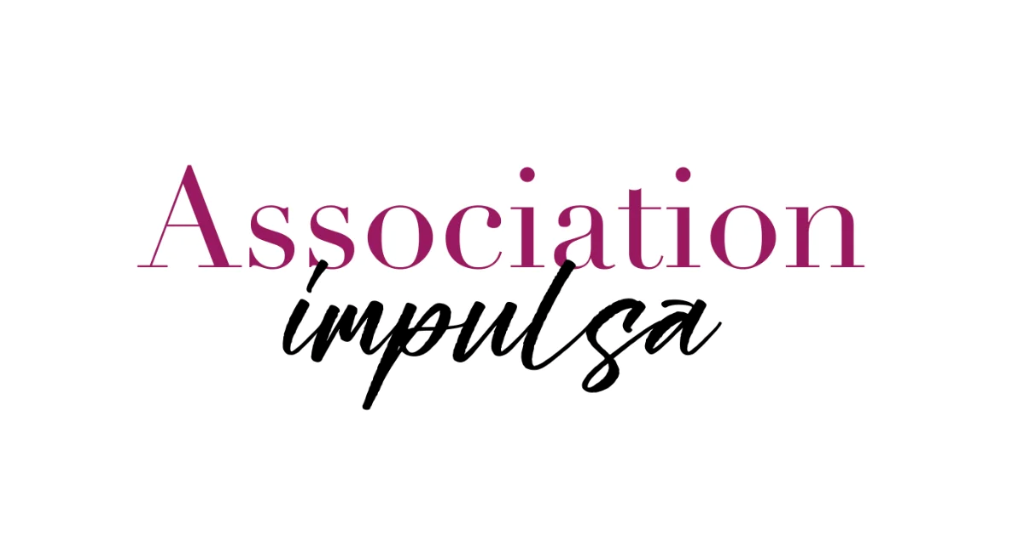
https://associationimpulsa.com/

5. CONTACT
Wondering what VeliD Advisory could bring to your business? Let's set up a conversation.

Schedule a 30-minute introduction

Prefer to ask a question first?
Contact form:
- Name
- Email
- Phone
- Company
- What would you like to talk about?
FOOTER — EVERY PAGE
[VELID LOGO]
Helping companies build international growth that lasts.

Navigation
Home · Approach · About · Network · Contact
CTA
→ Schedule an Introduction ← incl Calendly
A 30-minute introduction to meet each other, understand your ambitions and explore what VeliD could bring to the project.
NL · EN (And later ES and FR)
LinkedIn
VeliD Advisory

